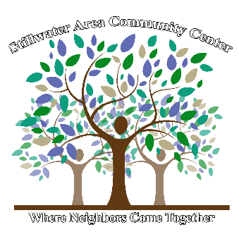
Stillwater Area Community Services Center Inc.
Where Neighbors Come Together…
Box 536 19 Palmer Street
Stillwater NY, 12170
Phone 518-664-2515
Fax 518-664-3590
www.sacc.online

2019 SACC Biddy Ball Program Registration Form
For children in pre-k (4 years old) thru grade 2 (7 or 8 years old)
Saturdays, January 4, 11, 18, and 25 & February 1, & 8 9-10 am
Last Name: First Name:
Name of Parents/Guardians:
Mailing and Street Address:
City: State: ZIP:
Home Phone: Cell Phone: Email:
Please initial here if we have your consent to use photographs of you for publicity purposes.
Health Limitations of player:
Is Parent/Guardian willing to coach? If yes, name:
How did you find out about Biddy Ball this year?
Registration deadline: December 27, 2019. Registration Fee: $30.00 Second Child Fee: $20.00
All fees must be paid at time of registration. Completed registration forms along with payment must be submitted to the SACC main office, or mailed to the above address. Please make checks payable to: Stillwater Area Community Center. Cash and Credit cards also accepted.

The Stillwater Area Community Center (SACC) is committed to providing quality programs that engage and provide fun for our community’s children. Please register your child for any program that interests him/her. If, after the first session of any SACC coordinated program, you find it is not going to work for them, 50% your money will be refunded. After the second, or any subsequent session, all monies are non-refundable. Thank you for understanding our policy.
For more information, contact Pete at 664-2515 x 239 or sportsandrec@sacc.online or visit our website.
Each child will receive a shirt and a medal.
Circle shirt size: Child Small 6-8 Child Medium 10-12 Child Large 14-16 Other:
Required: As consideration for being permitted to participate in activities sponsored by Stillwater Area Community Services Center and/or using equipment of said organization, each participant agrees to assume all liability for injury and/or damage resulting from such participation. Each participant further agrees to hold Stillwater Area Community Services Center and the Town of Stillwater free and harmless on account of any act of omission or commission or negligence on the part of said organizations or its officers, agents, volunteers, or representatives.

Signature of Parent/Guardian: Date:
Name of Parent/Guardian:
For Office Use Only:

Fee Paid: $ Cash or Check # Date Paid Received by:

